Life-Giving Sacrifices
Leviticus 7:28-34; 37-38; Romans 12:1-6a
S. Jewell S. McGhee
October 28, 2019

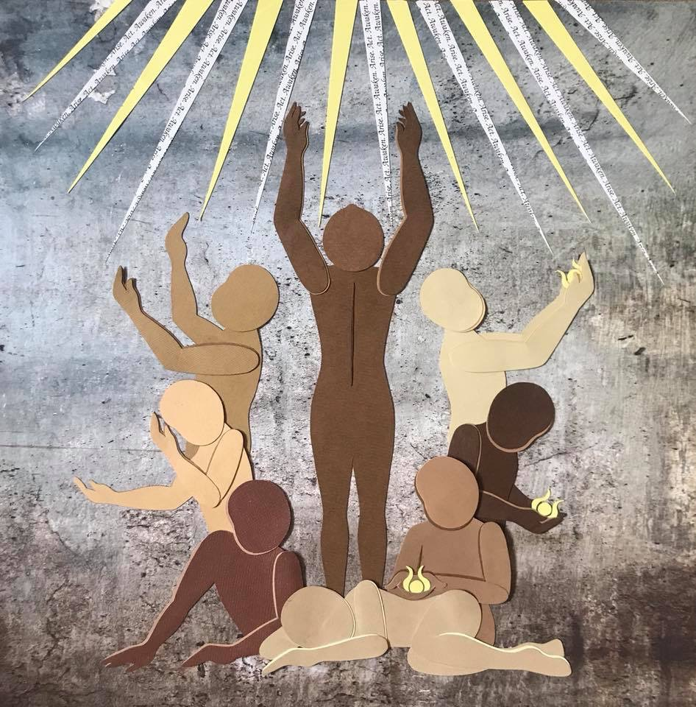
"Awaken, Arise, Act" 10x10, Paper on Paper by Rachel Asen
© Rachel Asen used with permission

Prelude Jacob Nault

Welcome Cory Lovell
God surround us, in all our pasts, presents and futures.
As we are welcomed into worship we acknowledge
the past, especially the indigenous communities, the Mississipian and the Sioux,
the present in all your beautiful diversity,
and future that we hope and work for.
God embrace us, in all our pasts, presents and futures.

Poem
That Hot Clock Hung High At Noon by Cory W. Lovell

She is not dead.
She is not
even.
Nor does she repeat.

She rhymes.
harmonizes.
marches on.
waits for no one.

She is not to be flirted with.
made good.
saved.
a damsel in distress.

She is a conqueror.
a revelator.
a dimension.
a salvation.

She hosts the rare sacrament of perspective.

Gathering Prayer S. Jewell S. McGhee

Music
Thou Lovely Source of True Delight Jacob Nault

Thou Lovely Source of True Delight
that I unseen adore
Unveil thy beauties to my sight
that I might love Thee more
Oh that I might love Thee more
(chorus)
Unveil thy beauties thy delights
From _the veil_ that hides it from my sight.
Unveil thy beauties thy delights
Lovely, Boundless Spring, O that I might love Thee more!

Thou Source of love, a boundless spring
Does quench my thirsting heart
Thrown round me like protecting wings
that I need ne'er depart
Held closely to thy heart
(chorus)
Unveil thy beauties thy delights
From _the thirst_ that hides it from my sight.
Unveil thy beauties thy delights
Lovely, Boundless Spring, O that I might love Thee more!

Tis here whene're my comforts droop and sin and sorrows rise
Thy love with cheering beams of hope my fainting heart supplies
My fainting heart supplies
(chorus)
Unveil thy beauties thy delights
From _the shame_ that hides it from my sight.
Unveil thy beauties thy delights
Lovely, Boundless Spring, O that I might love Thee more!

Then shall my soul with rapture trace the wonders of Thy love
But the full glories of Thy face are only know above
They are only known above
(chorus)
Unveil thy beauties thy delights
_Though your glory_ hides it from my sight.
Unveil thy beauties thy delights
Lovely, Boundless Spring, O that I might love Thee more!

Storytelling
Feasting in Africa Rev. Edith Chemorion

Embodied Scripture
Romans 12:1-6a (Paraphrase) Erin Outsen
Leviticus 7:28-34; 37-38 (NIV) Todd Pieper

Sermon
S. Jewell S. McGhee

Music
“I Need You, You Need Me” Dr. Lisa Pettis and Paul Vasile

I need you, you need me.
We're all a part of God's body.
Stand with me, agree with me.
We're all a part of God's body.
It is [God’s] will, that every need be supplied.
You are important to me, I need you to survive.
You are important to me, I need you to survive.
I pray for you, You pray for me.
I love you, I need you to survive.
I won't harm you with words from my mouth.
I love you, I need you to survive.
It is [God’s] will, that every need be supplied.
You are important to me, I need you to survive.

Benediction
S. Jewell S. McGhee

Collaborators:
Rachel Asen (Artist- Artwork) for commissions and prints; rachelepasen@gmail.com
Cory Lovell (Artist- Poetry) IG: @coryw.lovell
Rev. Edith Chemorion (Storyteller); ekchemorion@gmail.com
Jacob Nault (Musician- Composition, Pianist)
Todd Pieper (Actor- Embodied Scripture)
Erin Outson (Actor- Embodied Scripture)
Dr. Lisa Pettis (Musician- Singer)
Paul Vasile (Musician- Pianist)
Donna Simms (Artist- Installation)
Jerri Davenport (Head Artist- Installation) jerridavenportdesigns@gmail.com
Karen Piepmier (Collaborator- Installation)
Dakota Roberts (Collaborator- Bulletin Design)
Thank you also to Mark, Emma, Annie, Tarrah, Damayanthi and Tim for your love and support!

Works Cited:
Awaken, Arise, Act, 10x10, Paper on Paper by Rachel Asen © Rachel Asen used with permission.
Welcome and Gathering, S. Jewell S. McGhee.
That Hot Clock Hung High At Noon, Cory W. Lovell 2018.
Thou Lovely Source of True Delight, Lyrics: Anne Steele, Second verse lyrics and chorus by S. Jewell S. McGhee, Verse Music by Kevin Twit Music, Chorus music by Jacob Nault © 2019.
I Need You, You Need Me, music and lyrics written by David Frazier

